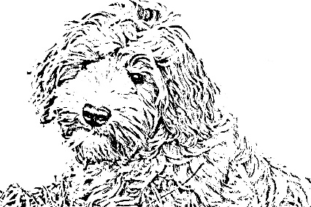
Siena Labradoodles

Applicants Name, address and Contact Numbers.
Name | Address | Contact No.

- What gender do you prefer male/female? Why?

- What is your preferred colour?
List 2

- What is your preferred size – Miniature, Medium or Standard?

- What is your preferred coat type of the Australian Labradoodle – Wool or Fleece?

- Circle what would you like your puppy to be?
- A couch potato
- Active
- Mainly inside
- Mainly outside

- What attracts you to the Australian Labradoodle?

- Have you researched the Australian Labradoodle and do you have an understanding of the breed – Yes or No?

- Have you ever owned a dog before – Yes or No?

- Do you presently own any dogs? If so what are the ages and what breed are they?

- Are you aware of the requirements in owning a dog, i.e., health care, facilities, lifetime companion – Yes or No?

- Do you know your dog will require brushing/combing once a week (minimum) and grooming at least 3/ to 4 times a year – Yes or No?

- Do you know the labradoodle breed is highly intelligent and will require training beyond puppy school – Yes or No?

- Do you value the importance of training your dog? If so have you enquired about the cost and commitment of training your puppy – Yes or No?

- Where will the puppy be living/sleeping?

- Do you have a safe environment in which to keep your dog: i.e. fenced yard – Yes or No?

- Is there an undercover/protected area where the puppy will spend its time when you are not at home – Yes or No?

- If you work full time, who is responsible for looking after your Labradoodle during the day and where would your dog be kept?

- Do you have any children? If so what are their ages?

- Should you find yourself in a position to no longer care for your Labradoodle, we request that you notify us so that we may assist in rehoming your pet. Do you agree to this? If not please explain why.

- How did you hear about us?

- How do you prefer to be contacted - phone or email or both?

- What is the best time to contact you?

